**SPOKE 6 – BIODIVERSITY and HUMAN WELLBEING**

A cura di - Gloria Bertoli1 & Hellas Cena2 (Spoke Leader); Rachele De Giuseppe2 (RA1 Leader); Flavia Guzzo3 (RA2 Leader); Paola Branduardi4 (RA3 Leader); Emanuela Dal Zotto5 (RA4 Leader)

1. Institute of Molecular Bioimaging and Physiology, National Research Council (IBFM-CNR), Via F.Cervi 93, Segrate, Milan, Italy.

2. Laboratory of dietetics and clinical Nutrition, Department of Public Health, Experimental and Forensic Medicine, University of Pavia

3. Department of Biotechnology, University of Verona, 37134 Verona, Italy.

4. Department of Biotechnology and Biosciences, University of Milano-Bicocca Piazza della Scienza 2 Milano 20126 Italy

5. Dipartimento di Scienze Politiche e Sociali Università degli Studi di Pavia

**1 VISION & MISSION**

Spoke 6 envisions sustainable, resilient cities centred on human well-being, where health and quality of life are enhanced through integrating NbS, technological innovation, and biodiversity conservation. Leveraging multidisciplinary approaches, the project aims to mitigate the negative impacts of the exposome by promoting solutions that seamlessly combine environmental sustainability, economic growth, and the development of new production processes and professional skills, paving the way for more liveable and inclusive urban futures.

The mission of spoke 6 is to promote innovative solutions to enhance urban health and well-being by mitigating the impact of biodiversity loss and exposome alterations. Waste materials are transformed into valuable bioactive molecules through NbS and advanced technologies, biological systems are investigated to characterize and valorise their unknown potential, integrating sustainability with economic development. Its mission includes creating innovative business models and new professional roles to build more liveable, resilient cities focused on human health and well-being.

**2. STRATEGIC OBJECTIVES**

The key research and innovation objectives of Spoke 6 are organized into four points, each corresponding to a specific Research Activity (RA) (Figure 1).

1. Explore the role of NbS in urban contexts, aiming to enhance biodiversity to mitigate the negative effects of the exposome on citizens' health and well-being (RA1 - Biodiversity, Exposome and Urban lifestyle).

2. Identify and develop innovative solutions (extraction, characterization, and study of bioactive molecules) to improve public health by integrating natural and technological approaches (RA2 - Bioprospecting and bioactivity).

3. Design and develop new technological processes to produce materials and molecules through sustainable processes, identify new biocatalytic pathways and activities, optimize and increase the extraction of bioactive molecules, including from urban waste materials, transforming them into resources for new applications (RA3 - Biotechnology and Biodiversity).

4. Develop innovative business models and foster the creation of new professional roles, promoting the integration of health and wellbeing, sustainability, and economic growth to enhance the quality of life in cities (RA4 - Biodiversity and Restoration Economy).

**Figure 1.** Spoke 6 is divided into four Research Activities

**3. STATE OF THE ART**

Spoke 6 tackles a critical, multidisciplinary challenge, connecting biodiversity, public health, and urban sustainability through NbS and technological innovation. Its objectives are structured into four Research Activities (RAs), each addressing key scientific and societal needs.

**RA1** focuses on leveraging NbS to enhance urban resilience against climate change and reduce health risks by addressing the exposome—a comprehensive concept of environmental exposures. However, there is a pressing need to better understand how biodiversity impacts human health and well-being, requiring interdisciplinary methods that integrate ecological and health data.

**RA2** explores bioprospecting as a promising avenue for public health, targeting the discovery of bioactive molecules from natural sources. Current gaps lie in developing efficient extraction and characterization techniques and integrating traditional and advanced biotechnologies with omics and artificial intelligence tools.

**RA3** emphasizes the potential of biotechnology to transform biodiversity into sustainable resources. It highlights the challenge of scaling processes for converting urban organic waste into bioactive molecules and materials, aligning with circular economy principles.

**RA4** addresses the emerging paradigm of integrating health, sustainability, and economic growth through innovative business models combining NbS and circular economy practices. Despite its potential to improve urban quality of life and foster ecosystem restoration, further research is needed to design effective operational models.

By bridging these gaps, Spoke 6 aims to deliver a systemic approach to urban challenges, fostering resilience, sustainability, and innovation while prioritizing citizen well-being through interdisciplinary collaboration.

**4. INNOVATION & RESEARCH PRIORITIES**

**RA1 - Biodiversity, Exposome and Urban Lifestyle.** RA1 is grounded in the exposome concept, which encompasses all environmental influences and their biological responses over a lifetime. It is categorized into the general external exposome (e.g., climate, air pollution), specific external exposome (e.g., chemical contaminants, lifestyle), and internal exposome (e.g., metabolic responses, inflammation). This framework links external exposures to internal responses and health outcomes, enabling comprehensive characterization of environmental factors to predict their impact on human health, particularly Non-Communicable Diseases (NCDs).

GENERAL OBJECTIVE. In this context, RA1 evaluates how the components of the external exposome (e.g., air quality), specific external exposome (e.g., lifestyle, nutritional factors, stress levels, occupation, socioeconomic dimension), and internal exposome (e.g., -omics and biochemical data) are associated with the presence of oxidative stress and inflammation, common factors in many chronic diseases. The study also considers the role of NbS in mitigating these effects.

WORKPLAN. The planned research activities in RA1 are developed on two distinct levels, allowing for exploration of the relationships between urban exposome, biological biomarkers, and health, providing both experimental and observational evidence to understand the impact of NbS and guide future interventions (Figure 2).

Level 1. Experimental Models. The first level involves the use of in vitro and in vivo experimental models to establish how NbS can mitigate the impact of air quality and how air quality affects health. In this case, a direct cause-effect relationship can be established. Specifically, the aim is to evaluate how exposing human lung epithelial BEAS-2B cells to increasing concentrations of air pollutants, both in the presence and absence of NbS, alters the oxidative stress and inflammation cellular pathways. Through cellular models, the inflammatory and oxidative status will be explored by analysing biomarkers, including miRNA, oxidative stress molecules, and pro- and anti-inflammatory cytokines.

Level 2. Cross-sectional analysis of existing and new cohorts. The second level concerns a cross-sectional evaluation based on existing and new cohorts to analyse the association between functional exposome and biomarkers. In this cross-sectional analysis, we investigate how external exposome factors (e.g., air quality), specific external exposome factors (e.g., lifestyle, nutritional factors, stress levels, occupational exposure, socioeconomic dimension), and internal exposome factors (e.g., inflammatory response, oxidative status, microbiome composition, and metabolomic profiles) are associated with human health and well-being in urban settings, considering also the presence of NbS. All collected data will be made available to the Spoke 6 scientific community for further analysis and to develop predictive models through the BIOMATRIX platform, funded under “Bando a Cascata” Calls in the Spoke 6 project.

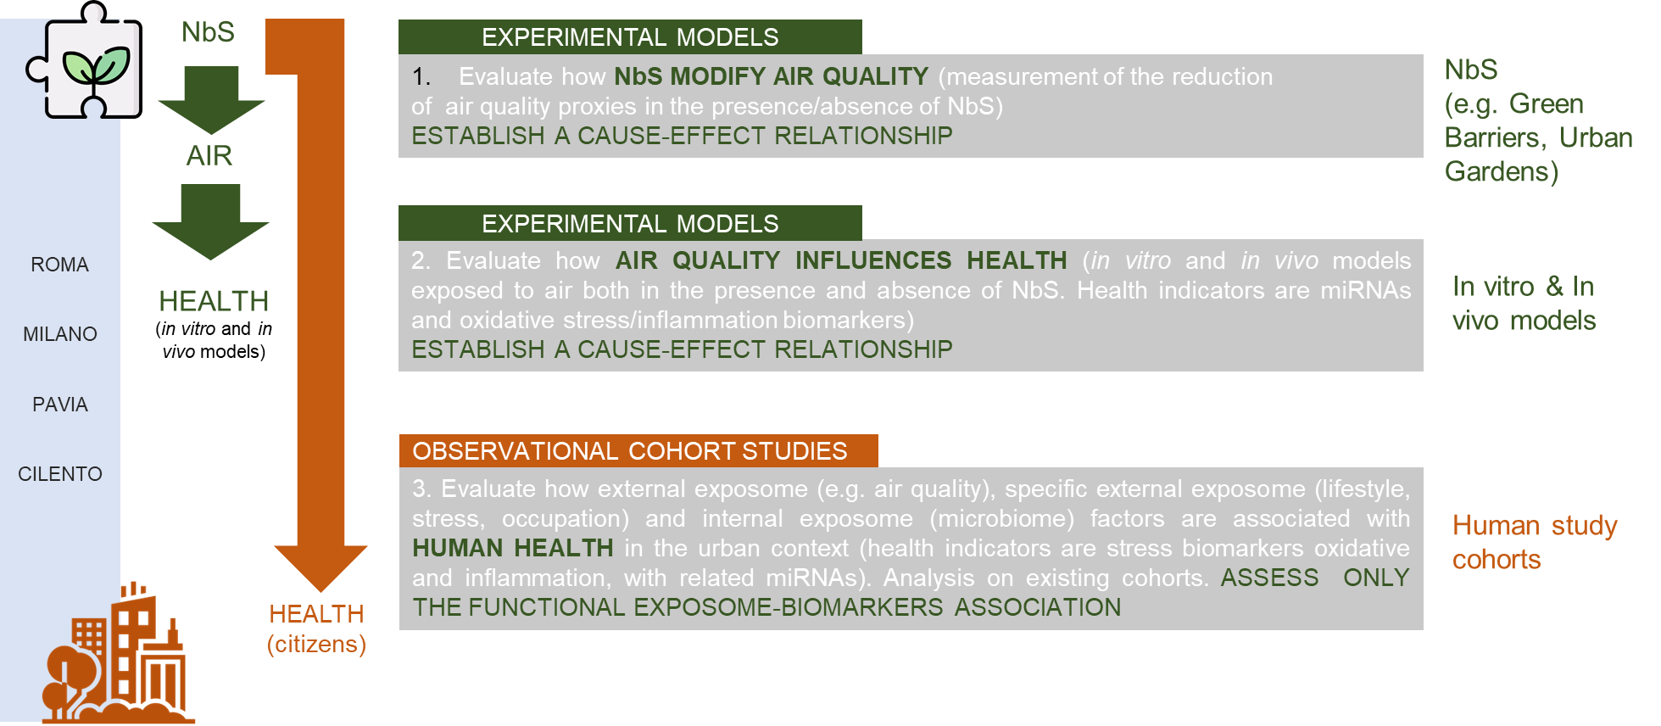

**Figure 2.** RA1 activities are developed on two distinct levels

The workplan is divided into eight distinct tasks (T):

Task 1.1. Biodiversity and air pollution: monitoring and prevention systems.  
Task 1.2.Mitigation of air pollutants through urban biodiversity: ultrafine particles and oxidative stress.

Task 1.3. Impact of NbS on air quality and citizen exposure.

Task 1.4. One Health and urban biodiversity: human response to exposome.

Task 1.5. Exposome and human Microbiome.

Task 1.6. Global health, urban biodiversity and lifestyle.

Task 1.7. Study of the effects of exposome modification by System Toxicology.

Task 1.8. Advanced technologies for monitoring and removing contaminants with NbS from water and soil.

EXPECTED RESULTS & APPLICATIONS. The research results will provide a fundamental basis for understanding how the integration of NbS in urban contexts, and thus the enhancement of biodiversity, can help mitigate the negative effects of the exposome on citizens' health and well-being. RA1 has applications spanning from clinical research to urban planning, to improve public health and general well-being in a sustainable context. Specifically, it will enable:

1. Identification of disease mechanisms – The integration of clinical, biological, and environmental data will allow for the identification of molecular processes altered by exposure to specific factors, such as pollution, diet, lifestyle, and occupational exposure. This will help clarify the interactions between the exposome and the onset or progression of NCDs.

2. Personalization of preventive and therapeutic medicine – The results will be useful for developing targeted approaches to disease prevention and management, adapting them to individual exposure profiles and environmental contexts.

3. Development of urban NbS – By evaluating the positive impact of NbS, the project will provide evidence to design urban and environmental interventions aimed at promoting well-being and reducing exposome-related risks.

4. Support for research and predictive modelling – The systematic collection of data represents a valuable resource for the scientific community, fostering the development of predictive models through innovative platforms like BIOMATRIX. These models can be used to anticipate the impact of environmental and sociodemographic variables on population health.

**RA2 – Bioprospecting and bioactivity.** Land plants, lacking movement and a nervous system, face environmental challenges through developmental plasticity and an extraordinary ability to produce and accumulate diverse chemical compounds (known as secondary or specialized metabolites). Various plant species have been used by humans since ancient times to treat different pathological conditions and still represent (or perhaps even more so today) an important resource for health. Moreover, despite the vast scientific literature on these topics, only a relatively small percentage of species and metabolites have been characterized in terms of phytochemistry and bioactivity. Additionally, since the distribution of secondary metabolites in plants reflects their respective metabolic pathways, which are subject to selective pressure, differences in composition increase with phylogenetic distance (Figure 3).

GENERAL OBJECTIVE. In this context, RA2 has implemented a bio-prospecting plan for plant species, based on phylogenetics, to explore species-metabolite-bioactivity relationships across all families of the Italian flora, from Bryophytes to Angiosperms. The aim is to identify and develop innovative solutions to improve public health and promote more sustainable agriculture.

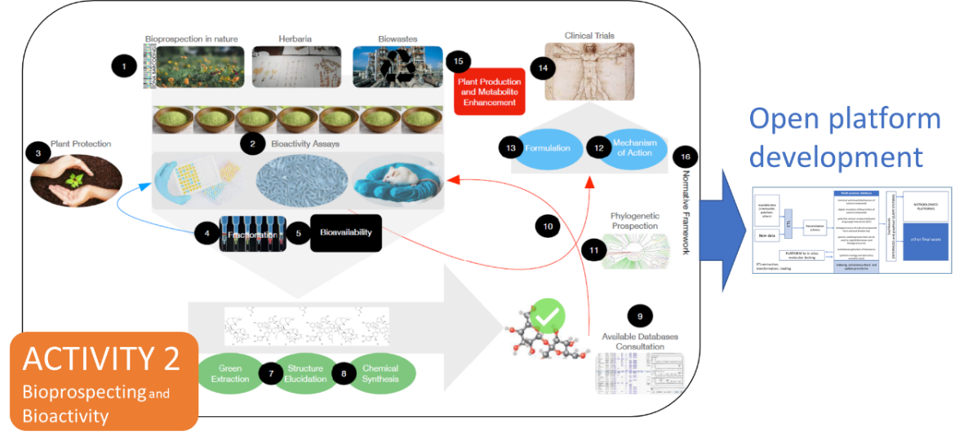

**Figure 3.** RA2 - Systematic Exploration and Bioprospecting of Plant Secondary Metabolites

for Health and wellbeing

WORKPLAN. The RA2 work plan is designed to enable a systematic exploration of the Italian flora and waste biomasses, focusing on their composition, the bioactivities of phytocomplexes and individual molecules, as well as the extraction processes of relevant bioactive metabolites. The planned research activities are organized into five tasks:

Task 2.1: Urban biodiversity, phylogeny and bioactive molecules

Task 2.2: Sustainability of extraction processes from biological matrices and scalability

Task 2.3: Characterization of bioactive molecules

Task 2.4: Plant biodiversity for human health.

Task 2.5: Bioinformatics High Throughput Screening

EXPECTED RESULTS & APPLICATIONS. The approach adopted will enable a systematic exploration of plant secondary metabolites and their potential applications to improve human health (with particular focus on the prevention and treatment of non-communicable diseases) and to promote healthier and more sustainable agriculture. The approach will allow:

**1. Mapping specialized metabolites across all families of vascular and non-vascular Italian flora –** By using a systematic and phylogenetic bio-prospecting approach, a broad collection of plant extracts (from approximately 800 species) will be implemented to study and map secondary metabolic pathways and their end products across all relevant taxonomic groups of the Italian flora with potential applications.

**2. Identifying new bioactive molecules or molecules with novel bioactivities** – The identification of new bioactive molecules or molecules exhibiting previously unknown bioactivities will be conducted both on the species of the collection mentioned above and on waste biomasses. This will involve state-of-the-art analytical methods (such as high-resolution mass spectrometry and NMR) and a wide range of biological activity assays, including cell-free in vitro systems, in vitro cellular systems, and preclinical animal models.

**3. Developing new extraction protocols** – "Green" extraction systems will be employed to optimize the recovery of bioactive compounds.

**4. Developing new tools based on AI and machine learning for biomolecule characterization** – These tools will enable the generation of hypotheses regarding the activity of specific targets, which will subsequently be validated in the laboratory to investigate the mechanisms of action of the identified bioactive molecules.

**RA3 – Biodiversity and Biotechnology.** The rationale of RA3 is based on the characterisation and valorisation of biodiversity from a biotechnological point of view through the identification of microbial and/or enzyme-based bioprocesses capable of valorising the planet's resources while minimising impacts (*biomanufacturing*). For this reason, the use of residual biomasses is promoted, as well as the circularity of processes from “*cradle to grave*”, rethinking and redesigning the current industrial production of molecules and materials within the principles of the circular economy (safe and rational by design) and aiming at accomplishing the agenda of the Sustainable Development Goals (SDGs). Given the pervasiveness of the aims of this activity, the work is carried out on the following main axes:

Chemical platforms and materials: unlike energy, which can have different forms of supply, there is a pressing need to create competitive processes to produce chemical platforms, and to produce materials that at the end of their life can be reintroduced into biogeochemical cycles (SDG 11, 12 and 13).

Food and Beverages: The SDG 2 of the UN agenda (zero hunger) involves finding new sources of supply and improving the nutritional quality of food already available, while minimising waste.

New Enzymes and Bioactive Molecules: Incorporating human activities into biogeochemical cycles means having the microbial community as an ally, in particular by discovering, studying and using enzymes, which can allow us both alternative production and the degradation of materials (rationally designed); at the same time, activities will focus on the discovery and characterisation of new antibiotics and mechanisms of action, to address one of the major health emergencies of the coming decades (SDG 3).

GENERAL OBJECTIVE. The combination of the listed axes of work aims to contribute to the knowledge of the unknown biodiversity (such as genotype-phenotype correlations, characterisation of innovative materials as well as of enzymes and bioactive molecules), as well as of the natural environment in which it operates. At the same time the aim is to strengthen the role of biotechnology in industrial innovation and in the transition towards production models with a lower environmental impact, which are not linked to the depletion of natural resources and that can generate intellectual property and contribute to human health (Figure 4).

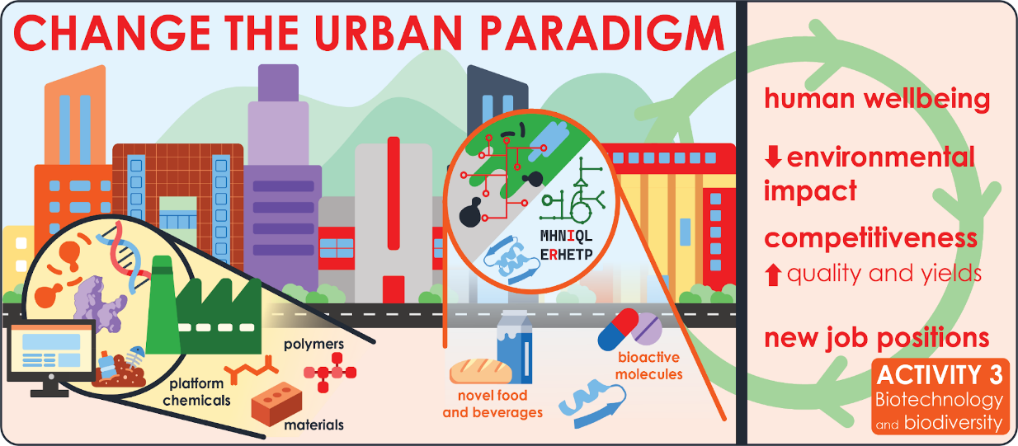

**Figure 4.** RA3 - Advancing Biodiversity Knowledge and Sustainable Biotechnology Innovation

WORKPLAN. The planned research activities in RA3 are organized into four tasks (T).

Task 3.1. Biodiversity and Biofoundry: microbial production of chemical platforms from renewable biomasses.

Task 3.2. Microbial biodiversity of natural or anthropogenic niches for production of primary interest: food, drinks and novel bioactive molecules.

Task 3.3. A rational by-design approach for novel polymers and materials

Task 3.4. Exploitation of the natural biodiversity for the discovery and production of bioactive small molecules.

EXPECTED RESULTS & APPLICATIONS. The results of the research are in line with the themes of the circular bioeconomy, with the three pillars of ‘zero waste’, the prolongation of the life cycle of resources and goods, and the return of matter to the natural biogeochemical cycles. These results inevitably have their foundations on innovation that allows for i) reducing the environmental impacts of bioprocesses concerning traditional processes; ii) planning aimed at reducing emissions in scopes 1, 2 and 3; iii) new job positions or the refurbishing of traditional ones, thanks to high-profile training, preferably in collaboration with companies (innovative and industrial doctorates, advanced courses on topics such as precision fermentation, quantitative physiology, deep sequencing, synthetic biology). RA3 is focused on:

1. Models of biomanufacturing and land-integrated biorefinery - Development of production processes based on the concept of biomanufacturing and examples of land-integrated biorefinery that enhance and support primary agricultural production, which in turn supports urban needs; examples of how the Design-Build-Test-Learn (DBTL) approach, enhanced by the possibilities offered by synthetic biology, can enhance metabolic engineering and fermentation processes; development of new processes linking non-biobased materials (traditional plastics) with biobased production and processes, thus extending the life cycle of the material and reducing emissions in area 3.

2. Biodiversity and biogeochemical cycles - Identification, development and production of new enzymes for efficient and ecologically safe wastewater treatment; new organic/inorganic materials and bacterial spores also derivatized with proteins/enzymes for use as pollutant adsorbents, (nano)reactors for waste treatment and bioactive molecules new bioactive molecules for use as nutraceuticals or new drugs, such as new classes of antimicrobials and antibiotics; new production processes for the fermentation of food and beverages that meet nutritional and market needs on the one hand, and mitigate the effects of climate change on the other (e.g., the excessive alcohol content of wines due to rising temperatures, resulting in high-sugar grapes ripening).

3. Development of biomaterials according to ‘rational by design’ logic - Redesign and rethinking of widely used polymers, with the objectives of: i) incorporating plant (secondary) metabolites, in general bio-products, to improve structural characteristics ii) adding intrinsic properties that lead to a prolonged lifespan in combination with an improved post-life profile concerning environmental impact (e.g: yarns of interest to the textile industry, agricultural tarpaulins and sacks) iii) new enzymes and new enzyme cocktails that can help speed up and improve the treatment of end-of-life products.

4. Discovery and functional description of bioactive small molecules - Discovery of new compounds and bioactives from natural biodiversity (also by applying abstraction and design principles). The aim is to define their function concerning translational applications (from *in vitro* to *in vivo* tests) and potential for industry. The development of sustainable and efficient production processes for structurally complex small molecules, e.g. chiral compounds, by fermentation with selected microorganisms and/or *extremosomes* discovered via the interpretation of (meta)genomic data.

**RA4 – Biodiversity e Restoration economy**. The rationale of RA4 is based on the relationship between biodiversity and innovation, both in economic and social fields. Enhancing biodiversity in urban areas (e.g., through restoration economy processes) stimulates the creation of new business models, natural capital management approaches, and the development of new professional roles.

GENERAL OBJECTIVE**.** The general objective of RA4 is to improve the ability of various stakeholders to manage biodiversity and generate economic, social, and environmental value within the urban ecosystem. This will be achieved through the identification of innovative business models, policy suggestions, and the development of new skills and professional roles.

WORK PLAN. The planned research activities in RA4 focus on businesses; institutional actors responsible for biodiversity management at various governance levels; and the professional profiles needed for its management and enhancement, involving simultaneous qualitative and quantitative methodology. RA4 activities are divided into two distinct tasks (T):

Task 4.1: Biodiversity and restoration economy.

Task 4.2: Biodiversity management and green jobs.

**Figure 5.** RA4 - Biodiversity, social innovation, and economic innovation

EXPECTED RESULTS & APPLICATIONS.

1. A comprehensive map of companies operating in the biodiversity sector, including the identification of innovative business models and a thorough analysis of key strengths, weaknesses, constraints, and opportunities. Application: Facilitating access to the collected data through a dedicated gateway to encourage cross-fertilization between companies and research institutions.

2. An analysis and reconstruction of the multi-level governance structure for biodiversity management, outlining the relationships among the various stakeholders involved. This is accompanied by an in-depth evaluation of the structure's key strengths, weaknesses, constraints, and opportunities. Application: Providing policy recommendations and actionable insights for decision-makers to enhance the management and promotion of biodiversity, with a specific focus on urban ecosystems.

3. A detailed catalogue of required and currently lacking professions and skills in the biodiversity labor market, aimed at addressing critical workforce gaps. Application: Designing targeted training programs, both within and beyond the University, to bridge existing skill shortages and support biodiversity-related initiatives.

**5. IMPACTS**

1. Scientific Impact **-** Spoke 6 significantly advances the understanding of the intricate relationship between biodiversity, the exposome, and human health. By employing a multidisciplinary approach that integrates Nature-based Solutions (NbS) with innovative technologies, the project fosters the development of predictive and molecular models. These models leverage comprehensive datasets to unravel disease mechanisms and support the design of personalized preventive and therapeutic interventions, as well as to develop innovative bioprocesses. The creation of the BIOMATRIX platform enhances data sharing among researchers, facilitating in-depth analyses and fostering collaborations across academic and industrial sectors. Similarly, the creation of environmental metagenomics databases will be a source of potential exploitation that will help broaden the landscape of collaborations, both at the research and industrial level.

2. Economic Impact -Spoke 6 promotes the development of innovative business models and the creation of new professional roles at the intersection of health, sustainability, and technology. By valorising urban waste materials for the extraction of bioactive compounds and as feedstock for biomanufacturing, the project opens new avenues for circular economy practices, with applications spanning the pharmaceutical, nutraceutical, and cosmetic industries. Moreover, the implementation of NbS encourages investment in green infrastructure, yielding positive economic outcomes at both local and national levels.

3. Social Impact -Spoke 6 aims to enhance public well-being by implementing measures that mitigate health risks associated with pollution and exposome disruptions. By fostering the development of more liveable and resilient urban environments through the integration of NbS, the project helps reduce environmental and health inequalities, thereby improving the quality of life, especially for vulnerable populations. Additionally, it raises public awareness about the importance of biodiversity and sustainable development, promoting greater civic engagement and community involvement. In addition, Spoke 6 collaborates with other Spokes to create content for participatory communication with civil society to raise awareness on the topic of biodiversity.

4. Environmental Impact -Spoke 6 underscores the value of urban biodiversity and proposes solutions to counteract the detrimental effects of habitat loss and pollution. The project’s innovative upcycling of urban waste and the design of biodegradable materials minimize waste generation while supporting the principles of a circular economy. NbS contributes to improve air, soil, and water quality, making cities more sustainable and resilient to the impacts of climate change. In this framework, Spoke 6 valuably exemplifies the integration of human health, production processes, protection and environmental conservation.

**6. COLLABORATIONS & STAKEHOLDER**

Spoke 6 adopts a multidisciplinary and innovative approach to addressing health, sustainability, and urbanization challenges, fostering stakeholder engagement across industries, academia, civil society, and governments. This collaborative framework ensures impactful research outcomes, technology transfer, and practical solutions that can be globally replicated.

**1. Stakeholder Engagement**

Industries: Key partners in transforming research into practical applications, industries contribute through investment in sustainable technologies and the creation of innovative business models, including bioactive molecule extraction from urban waste.

Universities: Essential for knowledge generation, universities provide professional training, scientific validation, and advanced intellectual resources, supporting predictive modelling and disseminating results.

Civil Society: Community involvement is crucial for co-designing NbS fostering acceptance and promoting sustainable behaviour through awareness and training programs.

Governments: Policymakers create regulatory frameworks, provide public funding, and facilitate public-private partnerships, ensuring scalability and adaptability of project outcomes to local needs.

**2. Strategies for Public-Private Partnerships -** Spoke 6 promotes collaboration through platforms for dialogue, co-financing mechanisms, pilot projects demonstrating NbS in urban settings, and formal R&D contracts between public and private entities.

**3. International Networks and Synergies -** Spoke 6 aims to establish global partnerships with research institutions and cities, sharing expertise and scaling solutions. Efforts include participating in international consortia, facilitating technology transfer through licenses and spin-offs, and aligning with global agendas like the UN Sustainable Development Goals (SDGs) for health, sustainable cities, and climate action. This comprehensive framework enables systemic innovation to build resilient, sustainable cities, driving positive societal and environmental impact.